Laveen Elementary School District
Vista Del Sur Elementary School
Aerial View of Site

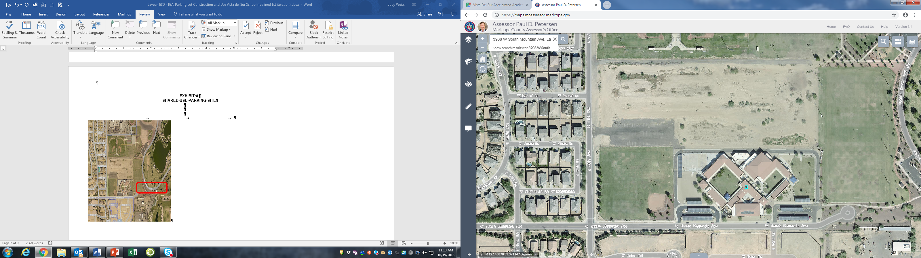

Shared Use Parking Lot Location – GRAPHIC DEPICTION ONLY

